



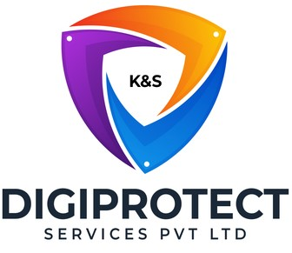

INITIAL
ASSESSMENT
REPORT

DATE: 28th June 2024
Collateral Legal

VERSION: 1.2.1

Document History
Document version | Remarks | Submitted  By | Submission  Date | Approved BY | Approval  Date
1.0 | First Draft | k&S Digiprotect | 14th June 2024
1.1 | Second Draft | k&S Digiprotect | 24th June 2024
1.2 | Final Draft | k&S Digiprotect | 25th June 2024
1.2.1** | Final Draft | k&S Digiprotect | 28th June 2024
** Only department name changed from Business Legal to Collateral Legal
K&S Digiprotect Services Pvt. Ltd.
Date of Discussion: Date of Release:
Version: 1.0
Date of Release: 15th April 2024

Table of Contents
Introduction 4
Objectives 4
General Information 5
SPOC Information 5
Department Hierarchy* 6
Observations 7
Data Flow Diagram (DFD) 8
Data Mapping and Inventory 9
Recommendations 10
Conclusion 11
Appendices 12
Appendix A 12

Introduction
India Shelter’s Collateral Legal Team ensures the legal integrity and compliance of collateral-related matters within the organization. This team comprises of collateral managers at various levels—regional, area, and branch—who work collaboratively to provide comprehensive legal oversight. The department is responsible for managing both internal and external teams that conduct meticulous document checks. This ensures that all legal matters are handled with precision and accuracy, particularly through a second thorough document verification process before the final disbursement of funds.
This report encapsulates critical insights for As-Is study, derived from the initial interview conducted with the Legal Department of India Shelter Finance Corporation Limited (ISFC) for the implementation of ISO/IEC 27001:2022 and compliance with the Digital Personal Data Protection Act (DPDPA).
The overarching objectives of this interview were dual fold: first, to gain an understanding of the departmental structure, and second, to delve into the core operational processes of the Legal Department. Additionally, the interview aimed to assess the existing information security practices, focusing on evaluating adherence to DPDPA requirements and the readiness for ISO/IEC 27001:2022 implementation.
By delving into the details of the department's organizational setup, operational workflows, and data handling procedures, this report aims to identify both the strengths and areas of improvement in information security management and DPDPA compliance within the department.

Objectives
- Understand the departmental hierarchy and reporting structure
- Learn the existing processes of ISFC’s Collateral Legal Department
- Mapping of existing processes with documented processes
- Offer recommendations to optimize the existing processes

General Information
Organization Name | India Shelter Finance Corporation Limited
Department Name | Collateral Legal
Date of the Assessment | 1st May 2024
Location | Basement, India Shelter HQ, Gurugram
Meeting Duration | 30 Minutes
Attendees (ISFC) | Pankaj Khurana, Dheeraj Yadav, Sunil Kumar Sharma
Attendees (Digiprotect) | Lalit Mohan Joshi, Sushil Menon, Aman Varma, Adhita Razdan

SPOC Information
Project SPOC: Dheeraj Yadav
Contact Information:
Email ID: dheeraj.yadav@indiashelter.in

Project Coordinator: Sunil Kumar Sharma
Contact Information:
Email ID: sunil.sharma2@indiashelter.in

Department SPOC: Pankaj Khurana
Contact Information:
Email ID: pankaj.khurana@indiashelter.in

Department Hierarchy*

* As informed during the meeting

Observations
S. No | Key Activities | Observations and Asks | Remarks
 | Collateral Legal Team  - Collateral legal teams consists of legal managers across various levels, including regional, area, and branch levels, to ensure thorough legal oversight and coordination in handling collateral-related matters.  - The department manages both internal and external teams that conduct thorough document checks and physical field visits (in selected cases) to ensure compliance and accuracy in legal matters.  - The team conducts a second thorough document verification check to identify any discrepancies or issues before the final disbursement of funds. | - Credit team is the internal stakeholder for business legal department.
 | Verification Process  - Post property checks by the technical team, legal checks are conducted by the internal legal team or external legal vendors.  - The external vendors don't have system rights and all the information is sent to them via emails. | - Business legal team has SLA’s defined with the external legal teams. These are shared via emails only.  - Currently the Operations department initiates the legal check, and the reports are received by the operations department which in turn sends them to the business legal team, however a process change is in progress where the Collateral legal team will initiate the checks and receive reports directly from the external legal vendors.

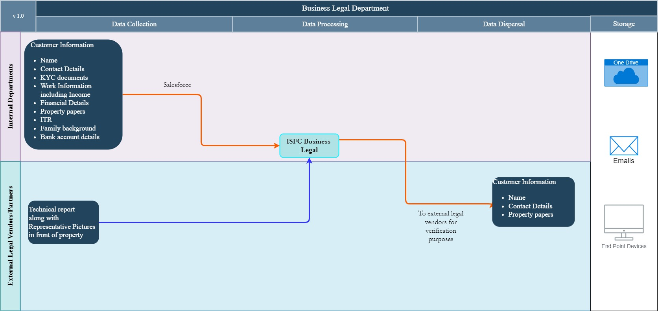
Data Flow Diagram (DFD)

Data Mapping and Inventory
S. No | Data Category | Description | Purpose | Data Owner | Storage Location | Data Classification* | Retention Period | Legal Basis
1 | Customer Information | Personal and property details of customers | To conduct legal checks and document verification | Business Legal Team | Internal database | PII/  Sensitive | Not Defined | Compliance with lending regulations
2 | Document Verification | Legal documents related to collateral | To ensure legal compliance and accuracy | Business Legal Team | Internal database | PII/  Sensitive | Not Defined | Compliance with legal standards
3 | Verification Reports | Reports from external legal vendors on property checks | To verify property and customer details | Business Legal Team | Internal database | Non PII/  Confidential | Not Defined | Regulatory compliance
4 | SLA Documents | Service Level Agreements with external legal teams | To define performance standards and timelines | Business Legal Team | Email | Non PII/  Restricted | Until updated/  replaced | Contractual obligation
5 | Compliance Records | Records of compliance checks and audits | To ensure adherence to legal and regulatory standards | Business Legal Team | Internal database | Non PII/  Confidential | As per regulatory requirements | Regulatory compliance
*Refer Appendix A

Recommendations
- Implement Robust Access Controls
- Implement role-based access controls (RBAC) so that only authorized personnel have access to specific data, minimizing the risk of unauthorized access.

- Encrypt Sensitive Data
- Encrypt all sensitive data both in transit and at rest. This ensures that even if data is intercepted during transmission or accessed without authorization, it remains unreadable and secure.

- Regular Security Audits
- Conduct regular security audits and vulnerability assessments to identify and mitigate potential security risks. This should include both internal systems and external vendors' systems to ensure comprehensive protection.

- Data Masking and Anonymization
- Use data masking and anonymization techniques for any sensitive information shared with external vendors. This reduces the risk of exposing personal identifiable information (PII) unnecessarily.

- Secure Communication Channels
- Replace email-based communication with secure, encrypted communication platforms for sharing SLAs and reports with external legal teams. This ensures that sensitive information is protected during transmission.

- Regular Training on Data Protection
- Provide regular training sessions for both internal and external teams on best practices for data protection and the importance of maintaining confidentiality. This will help in fostering a culture of security awareness.

- Monitor and Log Access
- Implement comprehensive logging and monitoring of all access to sensitive data. Regularly review these logs to detect and respond to any unusual or unauthorized access attempts.

- Vendor Management
- Include data protection clauses in contracts with external vendors and require them to adhere to the same standards of data protection as the internal teams. Regularly review and audit vendor compliance with these standards.

Conclusion
The Business Legal Team is essential in safeguarding India Shelter’s legal compliance and integrity, particularly in collateral-related matters. By implementing streamlined processes, enhancing communication, leveraging technology, focusing on continuous training, and monitoring performance, the team can further improve its efficiency and accuracy. These recommendations aim to strengthen the department's operations, ensuring seamless coordination and compliance, thereby supporting the overall business objectives effectively.
Key roles:
Business Legal Interaction and Verification:
- The legal department collaborates with business legal teams and collateral managers across various levels to ensure thorough legal oversight and handling collateral-related matters.
- The legal department manages both internal and external teams that conduct thorough document checks and physical field visits to ensure compliance and accuracy in legal matters.
- The legal team conducts a second thorough document verification check to identify any discrepancies or issues before the final disbursement of funds.

Appendices

Appendix A
Data Classification | Definition
Sensitive Data | Information that, if disclosed, altered, or destroyed without authorization, could cause significant harm to an individual, organization, or entity. This often includes financial records, medical information, and PII.
Restricted Data | Highly sensitive data tightly controlled due to legal, regulatory, or contractual requirements. Access is limited to authorized personnel, and any unauthorized disclosure may result in severe consequences.
Private Data | Information considered confidential and intended solely for specific individuals or groups within an organization. It requires protection from unauthorized access to maintain privacy and uphold confidentiality agreements.
Confidential Data | Privileged or proprietary information of an organization requiring protection from unauthorized access, disclosure, or alteration.
Public Data | Information that is freely available and accessible to the general public without restrictions or limitations. It does not contain sensitive or confidential information and can be openly accessed and used for various purposes such as research, analysis, and public interest initiatives.
PII (Personally Identifiable Information) | Data that can identify, contact, or locate an individual, either alone or in combination with other information. For example - names, addresses, official identifiers (Aadhar, Pan, DL, biometrics, etc).
Non-PII | Data that, while not personally identifiable, however may still require protection due to its sensitivity or confidentiality. This may include corporate financial information, proprietary research data, or internal communications.

---------------------------End of report for Collateral Legal------------------------------

